ComicCraft – Project Documentation

Project title
ComicCraft – AI Comic Creator Using Gemini Models

Project description
ComicCraft is an AI-powered web application that automates the creation of comic stories and illustrations based on user-provided prompts. It integrates Google Gemini models and Stable Diffusion to generate personalized comics with structured storylines, character dialogues and illustrations. Users provide a story prompt, character name, setting, narrative tone and preferred art style. Gemini Flash generates a structured five-panel outline, Gemini Pro generates narration and dialogue, Stable Diffusion generates panel illustrations, and the completed comic can be previewed and downloaded as a PDF.

Application scenarios / use cases
- A user with a story idea can enter the prompt and create a complete five-panel comic.
- Students and creative users can create personalized visual stories without professional drawing skills.
- Users can customize the character, setting, tone and art style.
- Users can review the generated comic panel-by-panel before exporting it.
- Users can download the final comic as a PDF for saving, sharing, printing or offline viewing.

Technical architecture overview
ComicCraft follows a modular web application architecture. The browser provides the user interface, FastAPI handles requests and workflow coordination, Gemini Flash generates the five-panel outline, Gemini Pro generates narration and dialogue, Stable Diffusion generates panel illustrations, layout_builder.py combines images with panel text, comic_preview.html displays the result, and exporters.py with FPDF generates the final PDF.
- Frontend: HTML, CSS and Jinja2 templates.
- Backend: Python and FastAPI, served locally using Uvicorn.
- AI story generation: Google Gemini Flash and Gemini Pro.
- Image generation: Stable Diffusion with Hugging Face Diffusers.
- Panel image storage: static/panels (D1).
- Exported PDF storage: static/exports (D2).
- PDF generation: FPDF.

Prerequisites
- A local environment capable of running the Python/FastAPI application.
- FastAPI and Uvicorn for running the backend application.
- The required Google Gemini API credentials configured through environment variables.
- The required Hugging Face credentials/token configured through environment variables for the image-generation workflow.
- Access to the local file system locations used for generated panel images and exported PDFs.
These prerequisites are derived from the technologies and configuration requirements documented in the project source.

Prior knowledge required
- Basic Python programming and FastAPI concepts.
- Basic HTML, CSS and Jinja2 templating.
- Basic understanding of API requests and environment variables.
- Basic understanding of generative AI model usage.
- Basic knowledge of image generation and PDF export workflows.

Project objectives
- Simplify and automate the comic creation process using Generative AI.
- Transform user-provided ideas into complete comic stories with illustrations.
- Reduce the time and effort required for manual story writing and image creation.
- Allow users to personalize characters, settings, story tones and art styles.
- Provide a simple interface for generating, previewing and downloading comics.
- Make comic creation accessible to beginners, students and creative enthusiasts.

System workflow
- User opens the ComicCraft web page.
- User enters the story prompt, character name, setting, tone and art style.
- FastAPI receives the submitted information.
- Gemini Flash generates a structured five-panel outline.
- Gemini Pro generates narration and character dialogue for each panel.
- Stable Diffusion generates a comic-style image for each panel.
- Generated panel images are stored in static/panels.
- layout_builder.py combines each image with its panel content.
- The comic preview is displayed panel-by-panel.
- The user reviews the generated comic.
- exporters.py and FPDF compile the comic into a PDF.
- The PDF is saved in static/exports and the export-success page is displayed.
- The user can save, share, print or begin another comic.

Milestone 1: requirement analysis & system design
The project identified the comic-creation problem, defined functional and non-functional requirements, created the customer journey, DFDs and user stories, and designed the proposed solution and architecture.

Milestone 2: environment setup & initial configuration
The project environment uses Python, FastAPI and Uvicorn for the application server, HTML/CSS/Jinja2 for the interface, Google Gemini APIs for story generation, and Stable Diffusion with Hugging Face Diffusers for image generation. Sensitive AI credentials are configured through environment variables.

Milestone 3: core system development
The core workflow was developed for user input, five-panel outline generation, narration and dialogue generation, comic image generation, panel organization and preview.

Milestone 4: integration & optimization
The AI modules, image generation, layout builder, preview page and PDF export were integrated into one workflow. The modular architecture separates the major components so they can be enhanced independently.

Milestone 5: testing & validation
The application was tested locally using the complete comic-generation workflow. The documented tests cover homepage access, user inputs, outline generation, story generation, image generation, preview, PDF download and FastAPI documentation access. Numerical performance measurements were not supplied in the source document and should be measured separately.

Deployment
The source project document confirms local deployment and testing using Uvicorn and the FastAPI application. The documented implementation provides a web interface and API endpoints while the generated panel images and PDF files are stored in local file-system directories.

Project structure
- main.py – FastAPI application entry point.
- routes.py – application routing and comic-generation workflow.
- gemini_flash.py – structured five-panel outline generation.
- gemini_pro.py – narration and dialogue generation.
- image_generator.py – Stable Diffusion image generation.
- layout_builder.py – combines panel images and text for the comic layout.
- exporters.py – PDF generation using FPDF.
- index.html / Jinja2 templates – user input interface and generated pages.
- comic_preview.html – panel-by-panel comic preview.
- export_success.html – export confirmation page.
- static/panels – generated panel images.
- static/exports – generated comic PDFs.

Results
The project document records successful local testing of the complete workflow and provides screenshots for the ComicCraft homepage, comic preview, PDF download and export-success page.
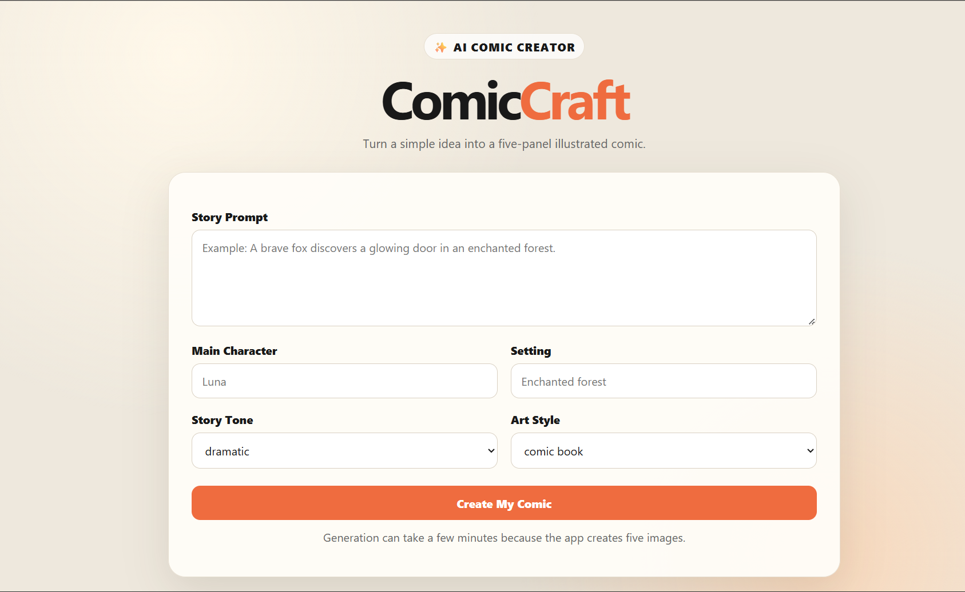
Screenshot 1 – ComicCraft Homepage
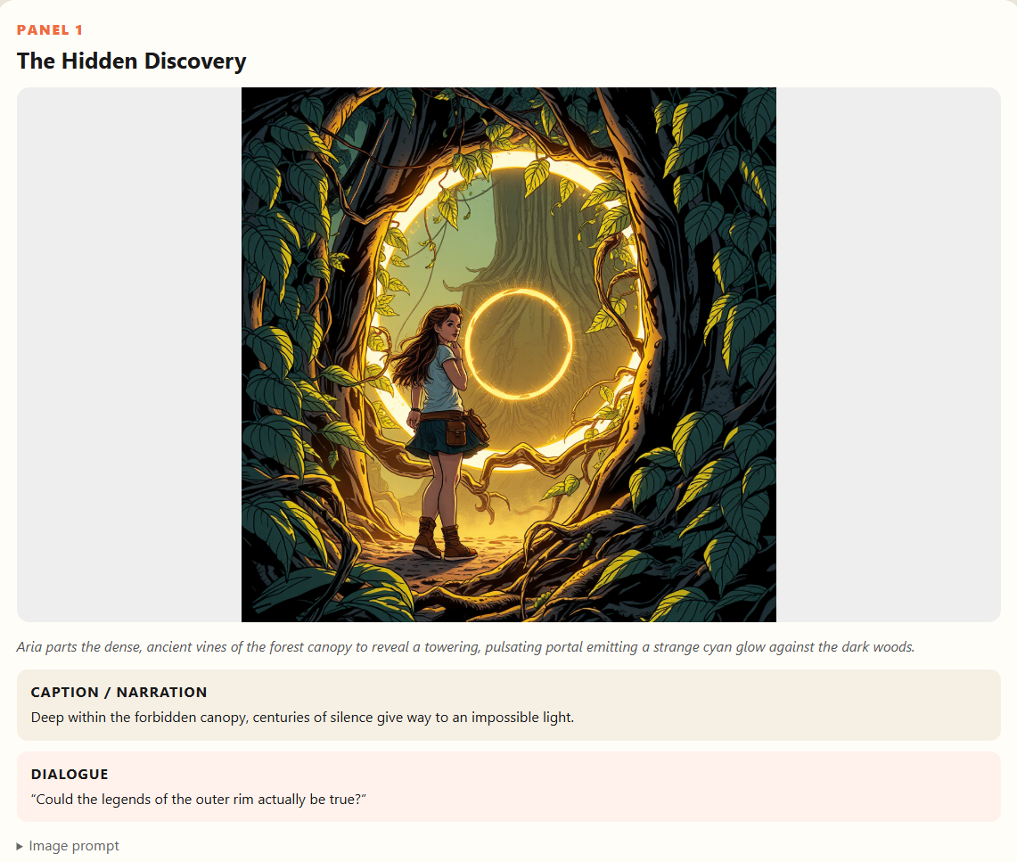
Screenshot 2 – Comic Preview Panel 1
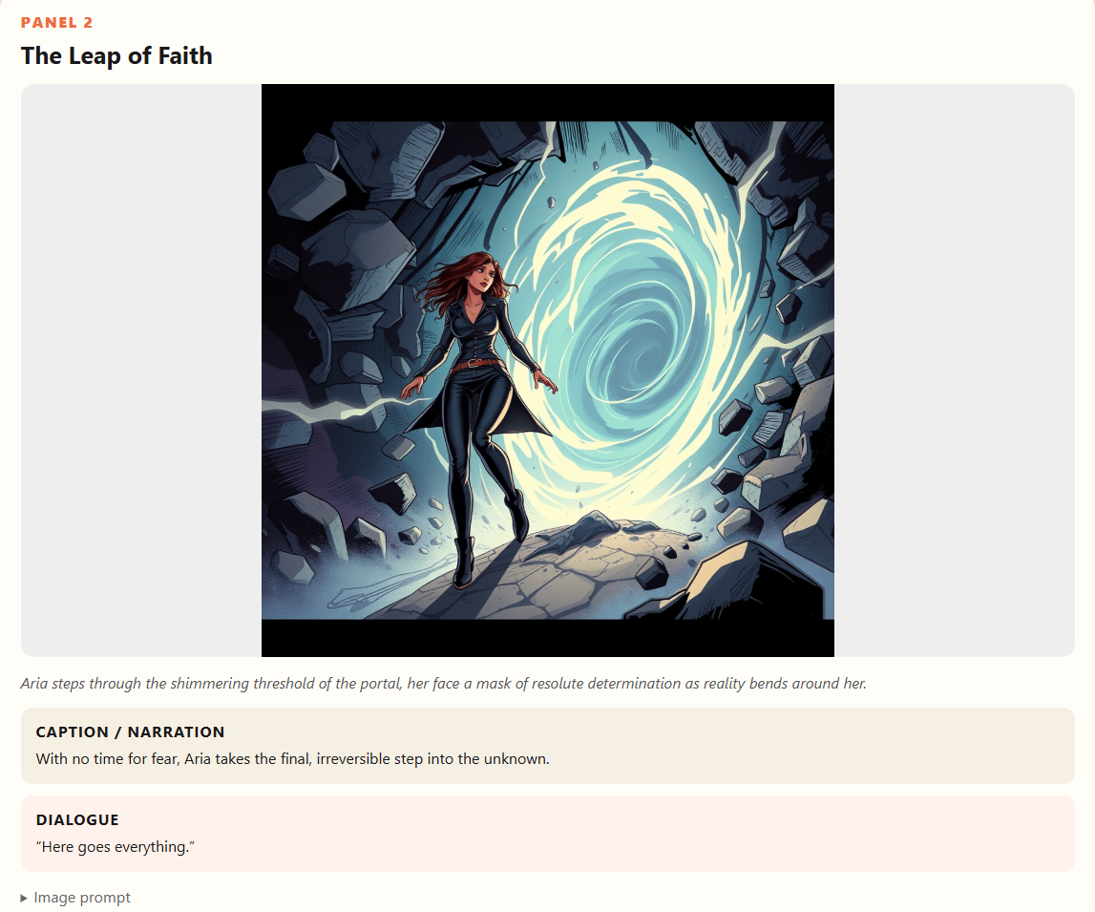
Screenshot 3 – Comic Preview Panel 2
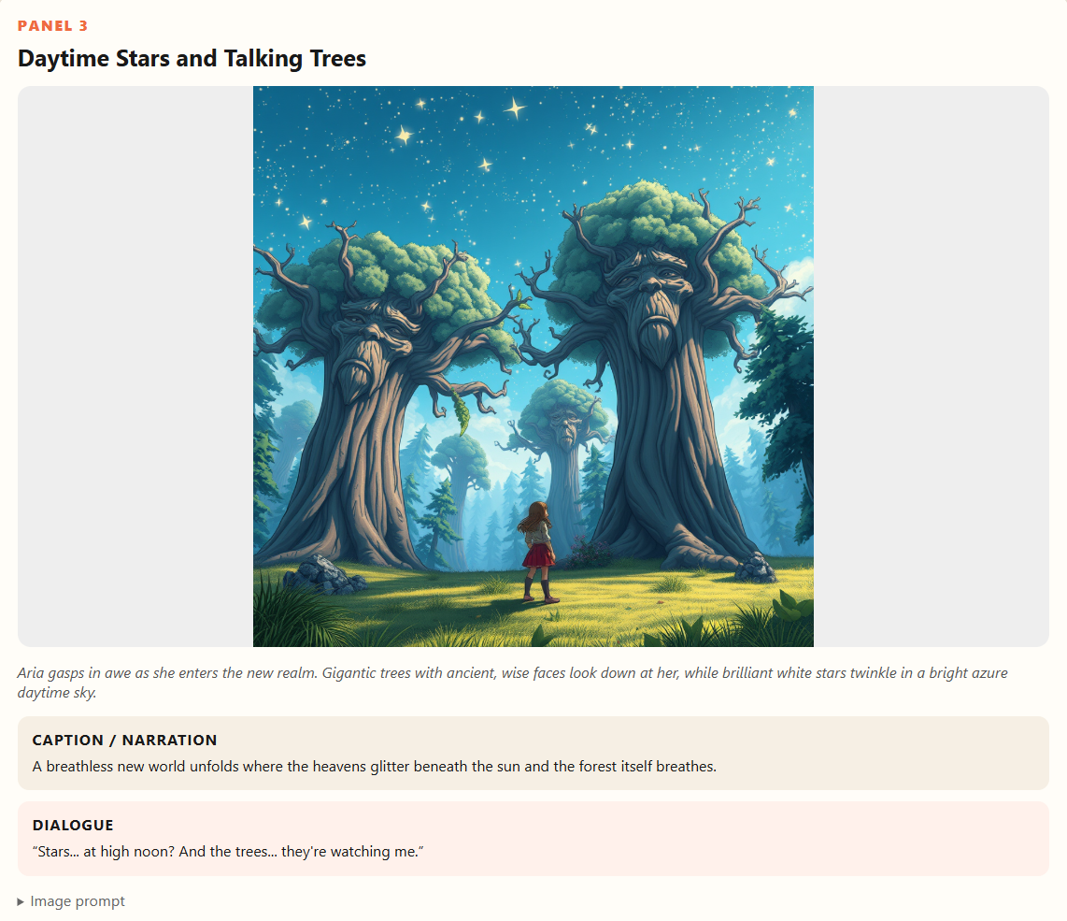
Screenshot 4 – Comic Preview Panel 3

Screenshot 5 – PDF Download
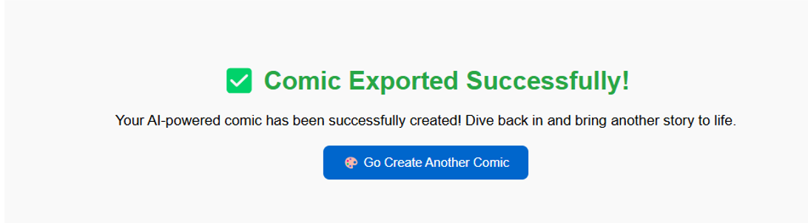
Screenshot 6 – Export Success

Advantages & limitations

Advantages
- Reduces the time required to create comics.
- Generates both stories and illustrations automatically.
- Allows users to customize their comics.
- Does not require professional drawing skills.
- Provides a simple web interface.
- Supports multiple art styles and story tones.
- Generates panel-by-panel comic content.
- Provides PDF export functionality.
- Combines text and image generation in one workflow.
- Modular architecture makes future improvements easier.

Limitations
- AI-generated content may not always match the user's exact expectations.
- Image generation can require significant computational resources.
- AI model/API availability may affect the application.
- API keys and external AI services must be configured correctly.
- The current version does not include user account management.
- The current version focuses on single comic generation.
- Generated content may require user review before final use.

Future enhancements
- User Authentication – Add login and registration functionality.
- User Profiles – Allow users to maintain personal comic collections.
- Comic Library – Store previously generated comics for later access.
- Multi-Page Story Arcs – Support longer stories beyond the current five-panel structure.
- Character Consistency – Improve consistency of characters across different panels.
- More Art Styles – Add additional image-generation styles.
- Comic Editing – Allow users to edit generated narration, dialogue and images before export.
- Cloud Deployment – Deploy the application to a cloud platform for public access.
- Mobile-Friendly Interface – Improve the interface for smartphones and tablets.
- Advanced Customization – Allow users to control panel layouts, image composition, dialogue placement and comic dimensions.

Conclusion
ComicCraft successfully demonstrates the use of generative AI for automated comic creation. The system combines Gemini Flash and Gemini Pro for story generation, narration and dialogue with Stable Diffusion for comic-style image generation. The application provides an end-to-end workflow beginning with a simple user prompt and ending with a complete downloadable comic. Users can customize the character, setting, tone and art style, preview the generated comic, and export it as a PDF.

